Machine Learning Homework 2_Report

2017112167 이수진

1. Read File

<Program Code>

#0

import pandas as pd

import numpy as np

filename = '/Users/soojinlee/python/hw2/heart-statlog.csv'

data = pd.read_csv(filename)

a_list = data.values

a_list

<Result>

1. Label Encoding

<Program Code>

#1

from sklearn.preprocessing import LabelEncoder

le = LabelEncoder()

getLabel=[]

tmp_list = a_list

for j in range(len(tmp_list[0])):

temp=[]

for i in range(len(tmp_list)):

temp.append(tmp_list[i][j])

indexing = {}

uniqueList = np.unique(temp)

for i in range(len(uniqueList)):

indexing[uniqueList[i]] = i

getLabel.append(indexing)

for j in range(len(tmp_list[0])):

temp=[]

for i in range(len(tmp_list)):

temp.append(tmp_list[i][j])

le.fit(temp)

list(le.classes_)

tempTrans = le.transform(temp)

for i in range(len(tmp_list)):

tmp_list[i][j] = tempTrans[i]

a_list_enc = tmp_list

df= pd.DataFrame(data=a_list_enc)

df.to_csv('a_list_enc.csv',index=False,header=False)

print(a_list_enc)

<Result>

1. Normalize
2. MinMaxScaler

<Program Code>

#2-1

from sklearn.preprocessing import MinMaxScaler

list_temp = a_list_enc

min_max_scaler = MinMaxScaler(feature_range=(0, 1))

min_max_scaler.fit(list_temp)

minmaxscaled_a_list = min_max_scaler.transform(a_list)

print(minmaxscaled_a_list)

<Result>

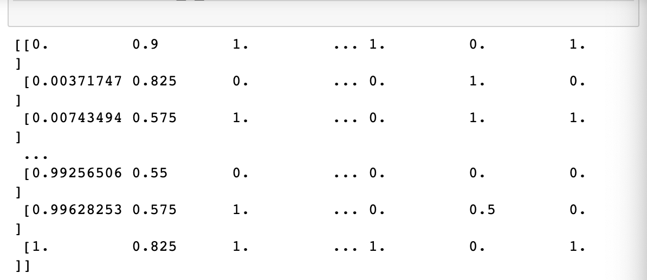

1. StandardScaler

<Program Code>

#2-2

from sklearn.preprocessing import StandardScaler

scaler = StandardScaler()

scaler.fit(a_list_enc)

a_list_enc_norm = scaler.transform(a_list_enc)

print(a_list_enc_norm)

import pandas as pd

df= pd.DataFrame(data=a_list_enc_norm)

df.to_csv('a_list_enc_norm.csv', index=False,header=False)

<Result>

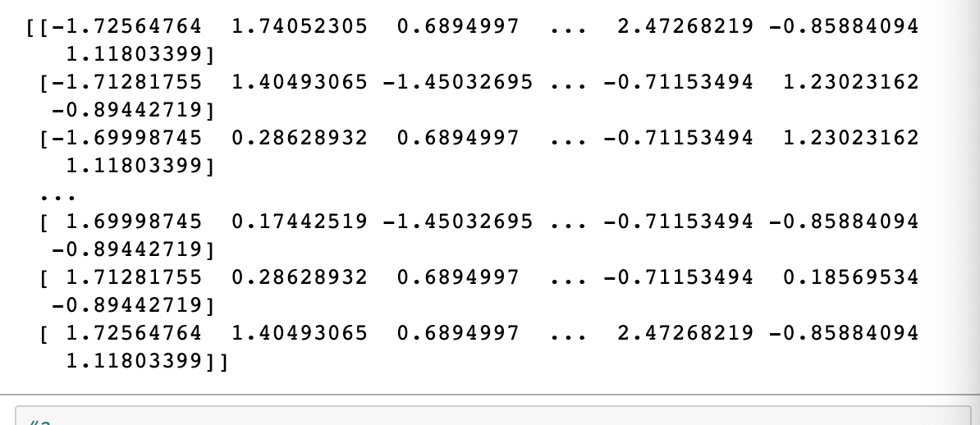

1. Divide_train_test

<Program Code>

#3

from sklearn.model_selection import train_test_split

from sklearn.linear_model import LinearRegression

X_data=[]

for i in range(len(a_list_enc_norm)):

X_data.append(a_list_enc_norm[i][:len(a_list_enc_norm[0])-1])

Y_data=[]

for i in range(len(a_list_enc)):

Y_data.append(a_list_enc[i][-1])

X_train, X_test, Y_train, Y_test = train_test_split(X_data, Y_data, test_size=0.3, random_state=42)

1. Running Neural Network

<Program Code>

#4

from sklearn.neural_network import MLPClassifier

from sklearn.metrics import classification_report, confusion_matrix, accuracy_score

#a

accpp0=[]

clf = MLPClassifier(hidden_layer_sizes=(10), max_iter=100)

clf.fit(np.array(X_train), np.array(Y_train))

predictions = clf.predict(X_test)

accpp0.append(accuracy_score(Y_test, predictions))

print(classification_report(Y_test, predictions))

print(confusion_matrix(Y_test, predictions))

print(accuracy_score(Y_test, predictions))

clf = MLPClassifier(hidden_layer_sizes=(40), max_iter=100)

clf.fit(np.array(X_train), np.array(Y_train))

predictions = clf.predict(X_test)

accpp0.append(accuracy_score(Y_test, predictions))

print(classification_report(Y_test, predictions))

print(confusion_matrix(Y_test, predictions))

print(accuracy_score(Y_test, predictions))

clf = MLPClassifier(hidden_layer_sizes=(80), max_iter=100)

clf.fit(np.array(X_train), np.array(Y_train))

predictions = clf.predict(X_test)

accpp0.append(accuracy_score(Y_test, predictions))

print(classification_report(Y_test, predictions))

print(confusion_matrix(Y_test, predictions))

print(accuracy_score(Y_test, predictions))

#b

accpp=[]

clf = MLPClassifier(hidden_layer_sizes=(10,10), max_iter=100)

clf.fit(X_train, Y_train)

predictions =clf.predict(X_test)

accpp.append(accuracy_score(Y_test, predictions))

print(classification_report(Y_test, predictions))

print(confusion_matrix(Y_test, predictions))

print(accuracy_score(Y_test, predictions))

clf = MLPClassifier(hidden_layer_sizes=(40,40), max_iter=100)

clf.fit(X_train, Y_train)

predictions =clf.predict(X_test)

accpp.append(accuracy_score(Y_test, predictions))

print(classification_report(Y_test, predictions))

print(confusion_matrix(Y_test, predictions))

print(accuracy_score(Y_test, predictions))

clf = MLPClassifier(hidden_layer_sizes=(80,80), max_iter=100)

clf.fit(X_train, Y_train)

predictions =clf.predict(X_test)

accpp.append(accuracy_score(Y_test, predictions))

print(classification_report(Y_test, predictions))

print(confusion_matrix(Y_test, predictions))

print(accuracy_score(Y_test, predictions))

<Result>

<Program Code>

#4-2

import matplotlib.pyplot as plt

x_array = [10,40,80]

plt.plot(x_array, accpp, color ="red", marker='s')

plt.plot(x_array, accpp0, color ="blue", marker='s')

plt.title('relationship between accuracy and hidden layer/nodes')

plt.show()

<Result>

<Program Code>

#4-3

arr1 = []

clf = MLPClassifier(hidden_layer_sizes=(3,3,3), activation='identity',max_iter=200)

clf.fit(X_train,Y_train)

pred = clf.predict(X_test)

arr1.append(accuracy_score(Y_test,pred))

print(confusion_matrix(Y_test,pred))

print(classification_report(Y_test,pred))

#4-3

arr1 = []

clf = MLPClassifier(hidden_layer_sizes=(3,3,3), activation='identity',max_iter=200)

clf.fit(X_train,Y_train)

pred = clf.predict(X_test)

arr1.append(accuracy_score(Y_test,pred))

print(confusion_matrix(Y_test,pred))

print(classification_report(Y_test,pred))

#4-3

arr1 = []

clf = MLPClassifier(hidden_layer_sizes=(3,3,3), activation='logistic',max_iter=200)

clf.fit(X_train,Y_train)

pred = clf.predict(X_test)

arr1.append(accuracy_score(Y_test,pred))

print(arr1)

print(confusion_matrix(Y_test,pred))

print(classification_report(Y_test,pred))

#4-3

arr1 = []

clf = MLPClassifier(hidden_layer_sizes=(3,3,3), activation='tanh',max_iter=200)

clf.fit(X_train,Y_train)

pred = clf.predict(X_test)

arr1.append(accuracy_score(Y_test,pred))

print(arr1)

print(confusion_matrix(Y_test,pred))

print(classification_report(Y_test,pred))

#4-3

arr1 = []

clf = MLPClassifier(hidden_layer_sizes=(3,3,3), activation='relu',max_iter=200, momentum=0)

clf.fit(X_train,Y_train)

pred = clf.predict(X_test)

arr1.append(accuracy_score(Y_test,pred))

print(arr1)

print(confusion_matrix(Y_test,pred))

print(classification_report(Y_test,pred))

<Result>

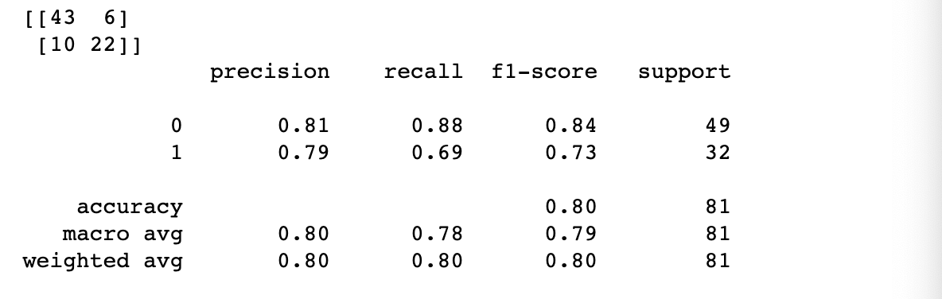

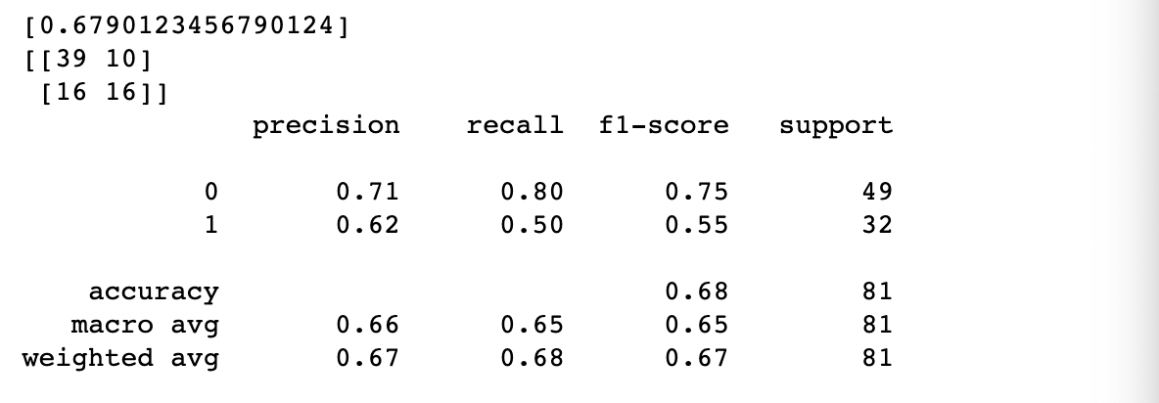

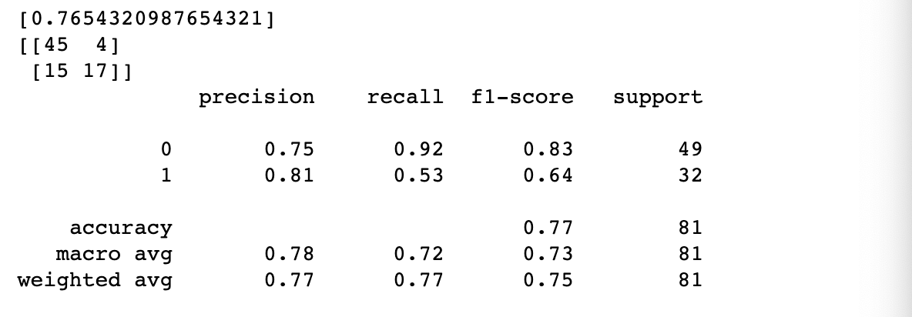

<Program Code>

#4-4

arr1 = []

clf = MLPClassifier(hidden_layer_sizes=(3,3,3), activation='relu',max_iter=200, momentum=0.2)

clf.fit(X_train,Y_train)

pred = clf.predict(X_test)

arr1.append(accuracy_score(Y_test,pred))

print(arr1)

print(confusion_matrix(Y_test,pred))

print(classification_report(Y_test,pred))

#4-4

arr1 = []

clf = MLPClassifier(hidden_layer_sizes=(3,3,3), activation='relu',max_iter=200, momentum=0.4)

clf.fit(X_train,Y_train)

pred = clf.predict(X_test)

arr1.append(accuracy_score(Y_test,pred))

print(arr1)

print(confusion_matrix(Y_test,pred))

print(classification_report(Y_test,pred))

#4-4

arr1 = []

clf = MLPClassifier(hidden_layer_sizes=(3,3,3), activation='relu',max_iter=200, momentum=0.6)

clf.fit(X_train,Y_train)

pred = clf.predict(X_test)

arr1.append(accuracy_score(Y_test,pred))

print(arr1)

print(confusion_matrix(Y_test,pred))

print(classification_report(Y_test,pred))

#4-4

arr1 = []

clf = MLPClassifier(hidden_layer_sizes=(3,3,3), activation='relu',max_iter=200, momentum=0.8)

clf.fit(X_train,Y_train)

pred = clf.predict(X_test)

arr1.append(accuracy_score(Y_test,pred))

print(arr1)

print(confusion_matrix(Y_test,pred))

print(classification_report(Y_test,pred))

#4-4

arr1 = []

clf = MLPClassifier(hidden_layer_sizes=(3,3,3), activation='relu',max_iter=200, momentum=0.8)

clf.fit(X_train,Y_train)

pred = clf.predict(X_test)

arr1.append(accuracy_score(Y_test,pred))

print(arr1)

print(confusion_matrix(Y_test,pred))

print(classification_report(Y_test,pred))

#4-4

arr1 = []

clf = MLPClassifier(hidden_layer_sizes=(3,3,3), activation='relu',max_iter=200, momentum=0.8)

clf.fit(X_train,Y_train)

pred = clf.predict(X_test)

arr1.append(accuracy_score(Y_test,pred))

print(arr1)

print(confusion_matrix(Y_test,pred))

print(classification_report(Y_test,pred))

#4-5

arr1 = []

clf = MLPClassifier(hidden_layer_sizes=(3,3,3), activation='relu',max_iter=200, momentum=0.8,learning_rate='constant')

clf.fit(X_train,Y_train)

pred = clf.predict(X_test)

arr1.append(accuracy_score(Y_test,pred))

print(arr1)

print(confusion_matrix(Y_test,pred))

print(classification_report(Y_test,pred))

#4-5

arr1 = []

clf = MLPClassifier(hidden_layer_sizes=(3,3,3), activation='relu',max_iter=200, momentum=0.8,learning_rate='invscaling')

clf.fit(X_train,Y_train)

pred = clf.predict(X_test)

arr1.append(accuracy_score(Y_test,pred))

print(arr1)

print(confusion_matrix(Y_test,pred))

print(classification_report(Y_test,pred))

#4-5

arr1 = []

clf = MLPClassifier(hidden_layer_sizes=(3,3,3), activation='relu',max_iter=200, momentum=0.8,learning_rate='adaptive')

clf.fit(X_train,Y_train)

pred = clf.predict(X_test)

arr1.append(accuracy_score(Y_test,pred))

print(arr1)

print(confusion_matrix(Y_test,pred))

print(classification_report(Y_test,pred))

#4-5

arr1 = []

clf = MLPClassifier(hidden_layer_sizes=(3,3,3), activation='relu',max_iter=200, momentum=0.8,learning_rate='adaptive',learning_rate_init=0.002)

clf.fit(X_train,Y_train)

pred = clf.predict(X_test)

arr1.append(accuracy_score(Y_test,pred))

print(arr1)

print(confusion_matrix(Y_test,pred))

print(classification_report(Y_test,pred))

#4-5

arr1 = []

clf = MLPClassifier(hidden_layer_sizes=(3,3,3), activation='relu',max_iter=200, momentum=0.8,learning_rate='adaptive',learning_rate_init=0.003)

clf.fit(X_train,Y_train)

pred = clf.predict(X_test)

arr1.append(accuracy_score(Y_test,pred))

print(arr1)

print(confusion_matrix(Y_test,pred))

print(classification_report(Y_test,pred))

<Result>

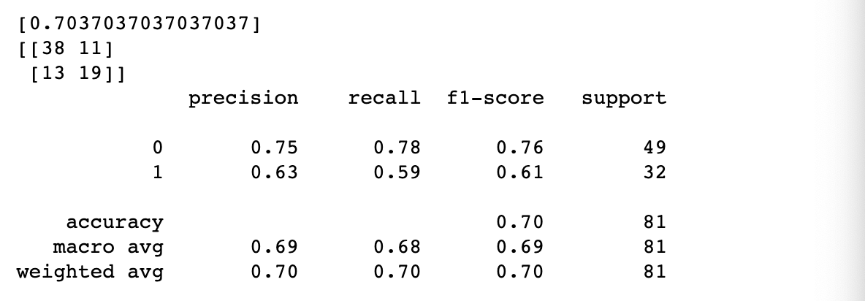

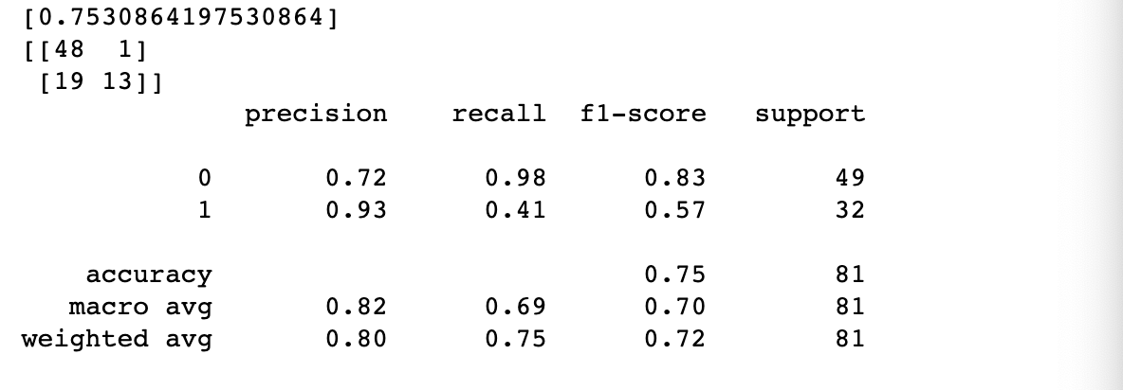

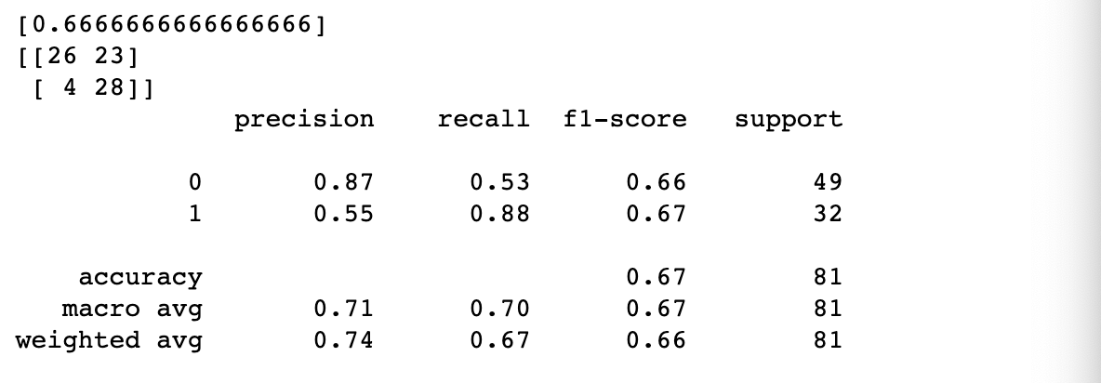

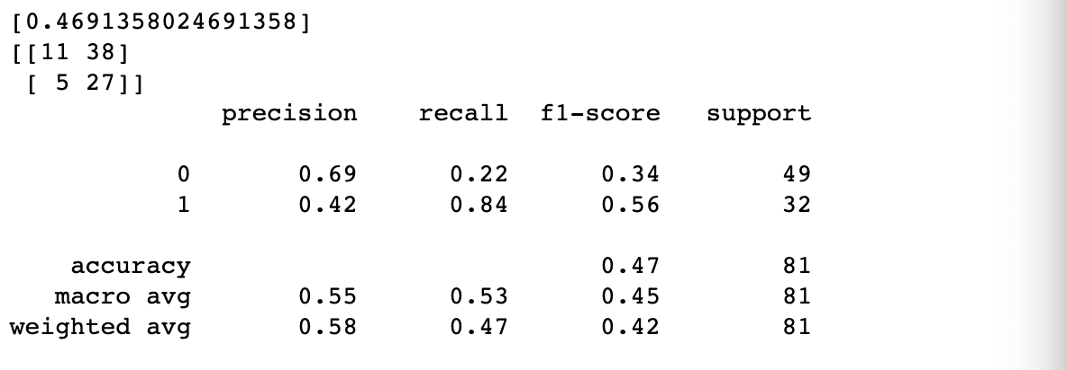

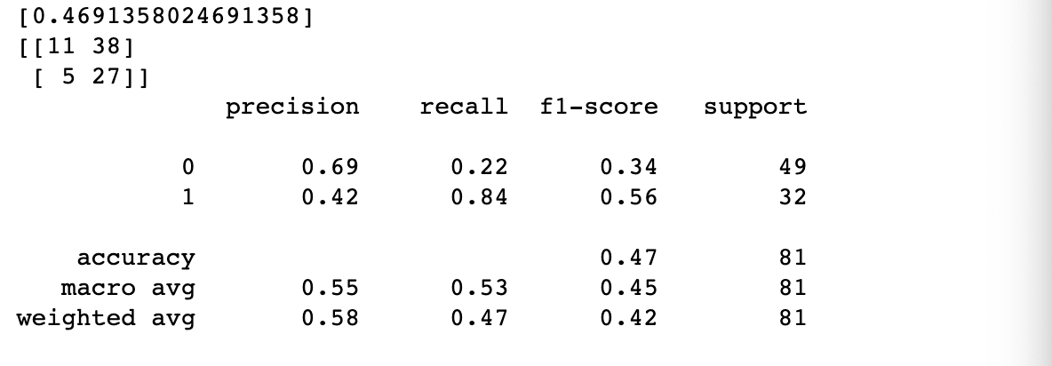

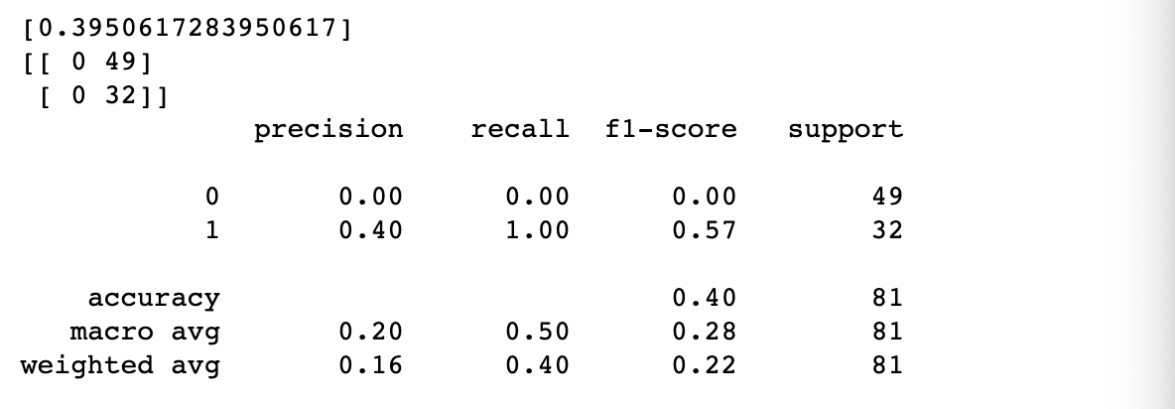

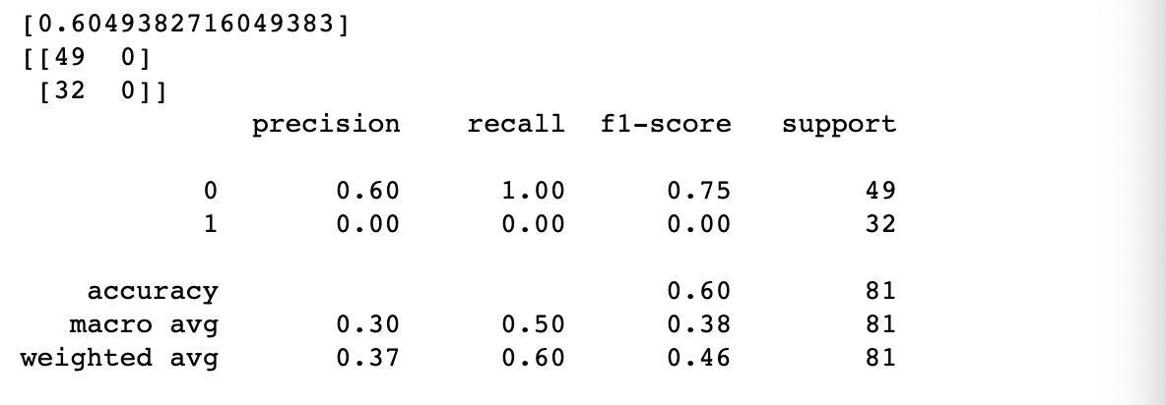

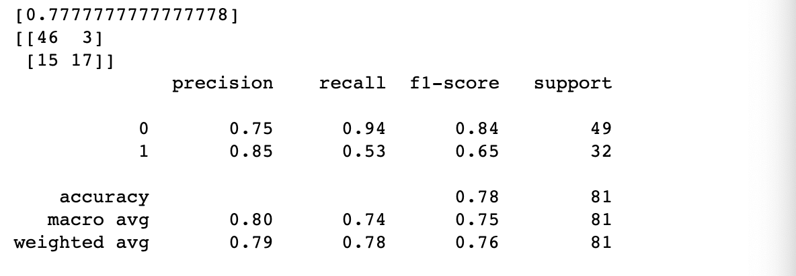

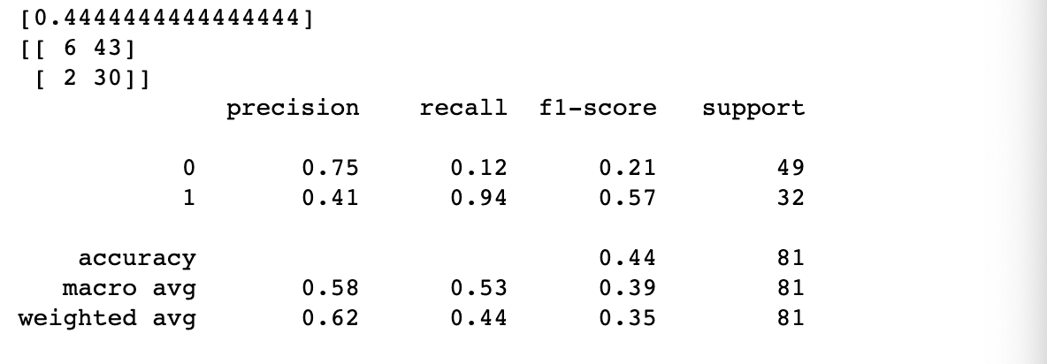

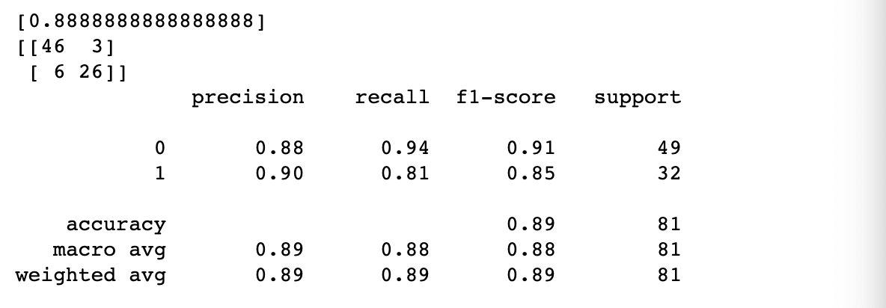

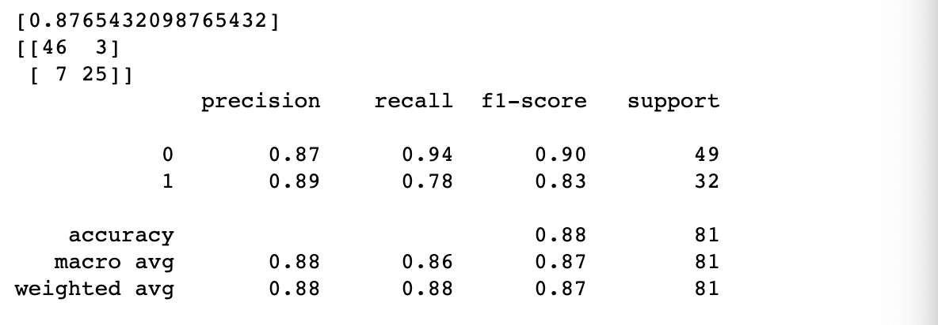

1. Discretization

<Program Code>

#5

from sklearn.preprocessing import KBinsDiscretizer

list_temp=a_list_enc

disc = KBinsDiscretizer(n_bins=4,encode='ordinal', strategy='uniform')

disc.fit_transform(list_temp)

a_list_enc_disc = list_temp

print(a_list_enc_disc)

df=pd.DataFrame(data=a_list_enc_disc)

df.to_csv('a_list_enc_disc.csv',index=False,header=False)

<Result>

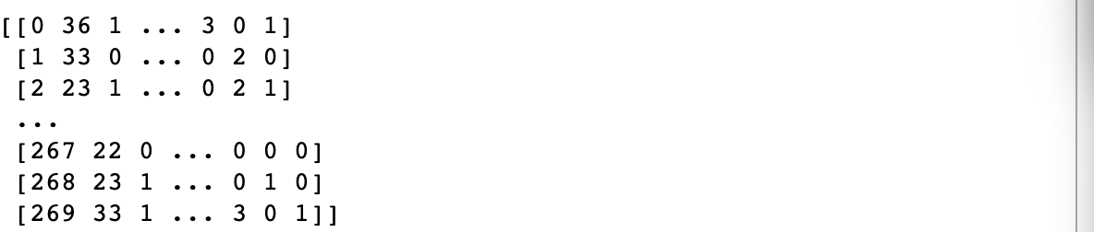

1. Running Decision Tree

<Program Code>

#6

from sklearn import tree

X_data2=[]

for i in range(len(a_list_enc_disc)):

X_data2.append(a_list_enc_disc[i][:len(a_list_enc_disc[0])-1])

Y_data2=[]

for i in range(len(a_list_enc)):

Y_data2.append(a_list_enc[i][-1])

X_train, X_test, Y_train, Y_test = train_test_split(X_data2, Y_data2, test_size=0.3, random_state=42)

scaler.fit(a_list_enc)

a_list_enc_norm = scaler.transform(a_list_enc)

print(a_list_enc_norm)

scaler.fit(X_train)

scaled_X_train = scaler.transform(X_train)

scaled_X_test = scaler.transform(X_test)

#entropy

clf = tree.DecisionTreeClassifier(criterion='entropy', max_depth=3, random_state=42)

clf.fit(scaled_X_train,Y_train)

Y_pr = clf.predict(scaled_X_test)

print(accuracy_score(Y_test, Y_pr))

#gini

clf = tree.DecisionTreeClassifier(criterion='gini', max_depth=3, random_state=42)

clf.fit(scaled_X_train,Y_train)

Y_pr = clf.predict(scaled_X_test)

print(accuracy_score(Y_test, Y_pr))

#6-2

import graphviz

togradata = tree.export_graphviz(clf,out_file=None, filled=True)

graph =graphviz.Source(togradata)

graph

<Result>

<Program Code>

#6-3

X_data2=[]

for i in range(len(a_list_enc_disc)):

X_data2.append(a_list_enc_disc[i][:len(a_list_enc_disc[0])-1])

Y_data2=[]

for i in range(len(a_list_enc)):

Y_data2.append(a_list_enc[i][-1])

X_train, X_test, Y_train, Y_test = train_test_split(X_data2, Y_data2, test_size=0.3, random_state=42)

scaler.fit(a_list_enc)

a_list_enc_norm = scaler.transform(a_list_enc)

print(a_list_enc_norm)

scaler.fit(X_train)

scaled_X_train = scaler.transform(X_train)

scaled_X_test = scaler.transform(X_test)

#entropy

clf = tree.DecisionTreeClassifier(criterion='entropy', max_depth=5, random_state=42)

clf.fit(scaled_X_train,Y_train)

Y_pr = clf.predict(scaled_X_test)

print(accuracy_score(Y_test, Y_pr))

#gini

clf = tree.DecisionTreeClassifier(criterion='gini', max_depth=5, random_state=42)

clf.fit(scaled_X_train,Y_train)

Y_pr = clf.predict(scaled_X_test)

print(accuracy_score(Y_test, Y_pr))

#6-3-2

togradata = tree.export_graphviz(clf,out_file=None, filled=True)

graph =graphviz.Source(togradata)

graph

<Result>



